ISME2014-XXXX

Title of the Industrial Research Proposal Paper (Times New Roman, 12pt, bold, center)

First Author¹, Second Author², Third Author³ (Times New Roman, 10pt, bold, center)

¹First Author's Address, Institutional Affiliation, Email Address (Times New Roman, 10pt, center)

²Second Author's Address, Institutional Affiliation, Email Address (Times New Roman, 10pt, center)

³Third Author's Address, Institutional Affiliation, Email Address (Times New Roman, 10pt, center)

Abstract
The abstract of the industrial research proposal paper is presented in this section. The paper should explain the selected industrial system and its functionalities as well as the related subsystems. Then, the facing problem is described with sufficient details and the necessity to solve these issues is expressed. Note that, the presented research proposal can either deal with fault detection and diagnosis of the systems or the development of the available systems. At the end, the authors should provide the research steps and the required experiments to solve the problem. It should be mentioned that the total number of pages should not exceed four pages.
Keywords: Keyword 1, Keyword 2, Keyword 3, Keyword 4, Keyword 5, Keyword 6, Keyword 7.

Description of the industrial system
In this section, the selected industrial system is described and the corresponding processes and the required subsystems are explained. The authors should clarify the importance of the selected industrial system and provide a basic introduction to the system and its applications in industry.

Industrial problem statement
The concerning problem should be defined in this section. The necessity of dealing with this problem and the possible solutions should also be discussed here. The presented industrial research proposal can cover the following topics:
- Development of an industrial system to meet the new demands in the industry
- Fault detection and diagnosis of the industrial systems
- Investigation and analysis of an industrial phenomenon
Note that, the standard format of the figures is shown in Figure 1. Besides, the reference numbers should be enclosed by square brackets on the baseline of the text, for example [1].

Research steps and expectations from the research proposal
The required steps to conduct the presented research project together with the necessary experiments and equipment are explained in this section. The expectations and the desired results set by the industrial employer can also be included. For the sake of completeness, the authors are free to add other details if the limit on the number of page is not exceeded.

Acknowledgments
This section enables the authors to thank those who have helped in carrying out the research

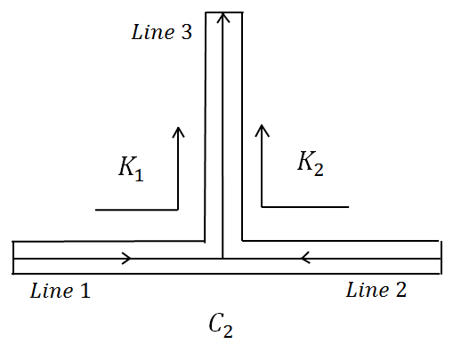
Figure 1: The different types of the T-shape connector

(1)

References
- Author, A., Author, B., and Author, C., 1994. “Article Title”. Journal Name, 1(5), May, pp. 1–3.
- Author, A., 1986. Book Name. Publisher Name, Address.
- Booklet, A., 1994. Booklet title. On the WWW, at http://www.abc.edu,May. PDF file.
- Inbook, A., ed., 1991. Book title, 1st ed., Vol. 2 of Series Title. Publisher Name, Publisher address, Chap. 1, pp. 1– 3. See also URL http://www.abc.edu.
- Incollection, A., 1991. “Article title”. In Collection Title, A. Editor, ed., 3rd ed., Vol. 2 of Series title. Publisher Name, Publisher address, May, Chapter 1, pp. 1–3. See also URL http://www.abc.edu.
- Inproceedings, A., 1991. “Article title”. In Proceedings Title, A. Editor and B. Editor, eds., Vol. 1 of Series name, Organization Name, Publisher Name, pp. 1–3. Paper number 1234.
- ASME, 2003. ASME Manual MS-4, An ASME Paper, latest ed. The American Society of Mechanical Engineers, New York. See also URL http://www.asme.org/pubs/MS4.html.
- Mastersthesis, A., 2003. “Thesis Title”. MS Thesis, University of Higher Education, Cambridge, MA, May. See also URL http://www.abc.edu.
- Misc, A., 2003. Miscellaneous Title. On the WWW, May. URL http://www.abc.edu.
- PhD thesis, A., 2003. “Thesis Title”. PhD Thesis, University of Higher Education, Cambridge, MA, May. See also URL http://www.abc.edu.
- Proceedings, A., ed., 1991. Volume Title, Vol. 1 of Proceedings Series, Organization Name, Publisher Name. See also URL http://www.abc.edu.
- Techreport, A., 2003. Techreport title. Progress report 1, University of Higher Education, Cambridge, MA, May. See also URL http://www.abc.edu.

